*– AP photo / Thinkstock*

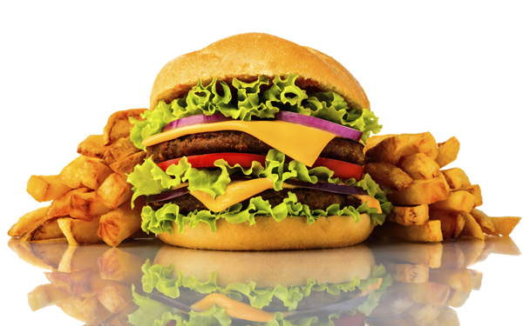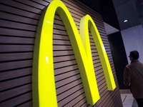

**Fast-food chains feel need to get “real”**

**By Candice Choi** *| Associated Press*

Fast-food chains have a New Year's resolution: Drop the junk.

Customers don't want food they think is overly processed. McDonald's, Taco Bell and other chains are trying to shed their reputation for serving meals that are loaded with chemicals.

"This demand for fresh and real is on the rise," said Greg Creed. He is CEO of Yum Brands. The company owns Taco Bell, KFC and Pizza Hut.

Creed said the company needs to be more transparent about ingredients. It also should use fewer preservatives, he said.

Recasting fast-food as "fresh" and "real" will be tricky. Terms like "fresh," ''real" and "healthy" have different meanings to different people.

Some companies are purging recipes of chemicals people might find unappetizing. PepsiCo, for instance, said it would remove brominated vegetable oil from Gatorade. The move came after a petition by a teenager. It complained the substance isn't approved for use in some markets overseas.

And fast-food chains are indicating they want to jump on the "clean label" trend too:

— McDonald's USA President Mike Andres said to expect some changes in early 2015. The company reported a 4.6 percent decline in U.S. sales for November.

"Why do we need to have preservatives in our food?" Andres asked, noting McDonald's restaurants go through supplies quickly. "We probably don't."

— Subway has new TV ads. They say its new chicken strips are free of artificial preservatives and flavors.

— Chick-fil-A said in 2013 it would remove high-fructose corn syrup from buns and artificial dyes from its dressings.

— Carl's Jr. has introduced an "all-natural" burger with no added hormones, antibiotics or steroids.

It's not clear how far fast-food companies will go in reformulating recipes. But the nation's biggest chains are facing growing competition. In the latest quarter, customer visits to traditional fast-food hamburger chains declined 3 percent from a year ago. That's according to market researcher NPD Group. Fast-casual chains, which are seen as a step up from traditional fast-food, saw visits rise 8 percent.

Part of the appeal of fast-casual chains is that they position themselves as being higher in quality. Chipotle touts its use of organic ingredients and meat from animals that were raised without antibiotics. The company sales at established locations surged 19.8 percent in the most recent quarter. And Panera announced it would remove artificial colors, flavors and preservatives from its food by 2016.

**Critical thinking challenge:** *If artificial ingredients cost more than natural ingredients, why would fast food companies remove the artificial ingredients?*

*- Posted on January 7, 2015*

**Summarizing**

LT: I can write a summary that condenses the text, includes only important information, uses only information from the text, and is written in my own words.

**Directions:** Read the article, then using the “Good Summaries-- The Five Criteria,” write a well-written summary below.

________________________________________________________________________________________________________________________________________________________________________________________________________________________________________________________________________________________________________________________________________________________________________________________________________________________________________________________________________________________________________________________________________________________________________________________________________________________________________________________________________________________________________________________________________________________________________________________________________________________________________________________________________________________________________________________________________________________________________________________________________________________________________________________________________________________________________________________________________________________________________________________________________________________________________________________________________________________________________________________________________________________________________________________________________________________________

**Summary Checklist:**

____ The summary is one-fourth to one-third as long as the original text

____ Contains all important information from the original text

____ Is in my own words

____ Spelling, punctuation, capitalization, and sentences are correct